SECRETARY OF STATE
STATE OF NEBRASKA

CERTIFICATE OF REGISTRATION
Exact Firm Name.
___________________________________________________________________ ________
(Exact Firm Name)

The Clerk of the Supreme Court of the State of Nebraska, does hereby certify that the officer, director, and shareholder of the above-named professional corporation, to wit:
Name, Residence, Address, City, State, ZIP.
_______________________ ____________________________________
(NAME, RESIDENCE ADDRESS, CITY, STATE, ZIP)

Name, Residence, Address, City, State, ZIP.
_______________________ ____________________________________
(NAME, RESIDENCE ADDRESS, CITY, STATE, ZIP)

PLEASE ATTACH SEPARATE LIST IF NEEDED

is duly licensed to practice law in the State of Nebraska, and that
Exact Firm Name. _________________________________________________________________ __
(Exact Firm Name)
complies in all respects with the provisions of the Nebraska Professional Corporation Act and of the canons, rules, and regulations imposed by this Court.
The address of the professional corporation at which the applicant proposes to perform

professional services is Address, City, State, ZIP.
______________________________________________.
(Address, City, State, Zip)
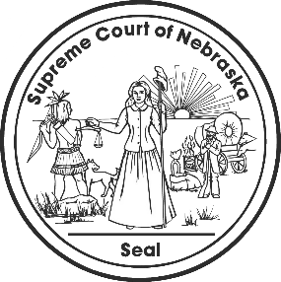
IN TESTIMONY WHEREOF, I have hereunto set my hand and caused to be affixed the Seal of the Court, in the City of Lincoln, this __________________.

__________________________________________________
Clerk, Supreme Court of Nebraska

This certificate expires one year from the date of issuance.

